IKC Parents Group – Ideas for Review
Current Suggestion for Forward Movement: Build Online Community Starting with Closed Facebook Group
Education & Awareness Team
IKC has been exploring and discussing the idea of an IKC Parents group. So far, draft materials and flyers have been shared with IKC members and provider contacts, as well as a family group representing children and youth with special healthcare needs. Finding and engaging those parents who may be most interested in serving as vaccine champions has proven challenging.
Other immunization coalitions have shared that forming an online community, such as a closed Facebook group, has been successful. Once an online community is formed, there is potential for further organization calling the group to action.
This document provides a suggested process for recruiting parents to form an online community of pro-vaccine parents on a closed Facebook group, administrated by IKC.
Suggested Process for Recruiting Parents
- Flyer is printed and distributed to IKC members, physicians and other health providers through KAFP/KAAP. Flyer is also electronically promoted on IKC social media and the IKC website.
- IKC members share the flyer with friends or family who could be interested in joining the group and personally invite them to join. Providers share the flyer directly with parents who will likely be interested, have flyers available in waiting areas, and share on social media pages.
- Parents interested in joining follow the link on the flyer and complete an online interest survey to:
  - Provide basic contact Information
  - Share how they found out about the IKC Parents group
  - Select the types of activities/focuses they would be interested in (e.g., online Facebook group, participating in webinar for parents, sharing positive messages on social media, attending portion of IKC meeting in person or remotely, etc.)
- IKC support staff follow-up with interested parents and provide more information about IKC and the Parent group.
- Once a Parent decides to join, they will be connected to a closed Facebook group with the other IKC Parent group members so they can meet other like-minded parents, share relevant information, and have group discussions.
Food for Thought
What is the vision for the IKC Parents group? What will this group accomplish?
What are the expectations and responsibilities of the IKC Parents group?
Examples:
- To create a supportive community for pro-vaccine parents
- To be advocates and liaisons for IKC and immunizations in their Kansas communities
- To partner together as parents to be a pro-vaccination voice in Kansas
- To provide relevant input from the parent perspective on IKC initiatives
- To serve as speakers and advocates promoting immunizations through personal stories as parents

Example Flyer or Social Media Post

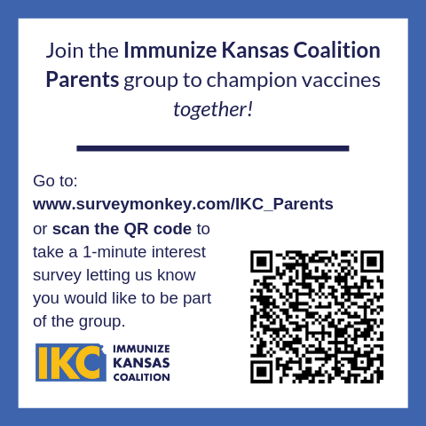
Example Flyer – Single-sided Half Sheet (Can be printed in Black/White)
